Project Report Template

Title of Project: AI-Powered Study Planner & Quiz Generator
Name of the Innovator: Praveena A
Start Date: 25-11-2025
End Date: 01-12-2025

Day 1: Empathise & Define
Step 1: Understanding the need
Problem to solve
University students, especially final - students, struggle to convert a long, dense syllabus into a realistic, time-bound study schedule. Common pain points include:

.Unstructured preparation and poor time allocation across topics.
.No personalized planning based on topic difficulty or individual strengths/weaknesses.
.Lack of quality practice questions for targeted revision.
.Difficulty tracking progress and maintaining consistency.
.Limited guidance for concept clarification without a tutor.

Who is affected
.Final-year college students preparing for term exams and vivas.
.Competitive exam aspirants needing structured study plans.
.Working students with limited daily study hours seeking efficient study routines.

How the problem was identified
- Interviews and peer discussions (study pain points, exam anxiety, revision gaps).
- Observation of ad-hoc planning, last-minute cramming, and inconsistent revision.
- Online research on learner productivity and planning challenges.
- Experiments using AI study aids to validate feasibility of automation.
Step 2: What is the problem?
Precise articulation
Students need a system that transforms syllabus text and exam timelines into:
*A personalized day-wise/weekly plan that respects daily hour limits.
*Auto-generated practice questions per topic (MCQs and short answers).
*A syllabus-aware AI chat assistant to clarify doubts quickly.
*They also need an interface that supports editing plans, tracking progress, and exporting printable content.
Why this matters
Reduces cognitive load and time wasted on planning logistics.
Increases study effectiveness by prioritizing weak topics.
Improves exam outcomes with consistent practice and targeted revision.
Builds learner autonomy and confidence.
Take-home findings after discussion
Strong demand for “paste syllabus → get plan” workflow.
Preference for difficulty tags (strong/medium/weak) and progress tracking.
Need for fast, printable question sets and plan exports.
Desire for a chat assistant grounded in the uploaded syllabus.

Day 2: Ideate
Step 3: Solution options (at least five)
- Web Study Planner: Create a personalized plan from syllabus, exam date, and daily hours; includes regeneration, edits, completion tracking.
- Smart Quiz Generator: Topic-based MCQs and short answers with explanations, difficulty levels, and printable exports.
- Syllabus-aware Chat Assistant: Answers questions using the user’s syllabus/notes; shows sources and handles follow-ups.
Analytics Dashboard: Visualizes progress, pending load, weak-topic focus, and suggested revisions.
Mobile-first Companion: Notifications for today’s plan, revision reminders, streaks, and micro-quizzes.
Collaborative Study Mode (optional extension): Group plans, shared quizzes, peer review.

Step 4: Chosen solution
An integrated full-stack web application—Smart Study Planner—combining:
AI-powered study planning,
AI quiz generation,
Syllabus-aware chat assistance,
Progress tracking and printable exports.

Step 5: Rationale for choosing this solution
- Directly maps to the most critical student needs: plan, practice, clarify.
- Modular architecture that is easy to extend and maintain.
- Frontend-first UX that reduces friction and speeds adoption.
- Clear separation of AI services to swap or scale models later.
- High educational impact for exam preparation and conceptual clarity.

Day 3: Prototype & Test
Step 6: Prototype overview
User flows and features
- Onboarding & Layout: Clean dashboard with sidebar (Dashboard, Study Plan, Quiz Generator, Chat Assistant, Profile/Settings), top bar with theme toggle and avatar.
- Syllabus Input & Exam Setup: Add subjects; paste syllabus; choose exam date; set daily hours; tag topics as strong/medium/weak.
- Study Plan Generator: Breaks syllabus into modules; allocates time based on difficulty and available days; outputs day-wise/weekly plan; editable and regenerable; mark-complete and track progress.
- Quiz Generator: Select subject/topic, type (MCQ/short), difficulty, quantity; outputs questions with options, correct answer, explanations; copy-all and printable export.
- Chat Assistant: Syllabus-aware responses; message history; loading states; basic error handling.
- Authentication & Profile: Email/password, name, email, default daily hours, theme preferences.

Architecture and stack

- Frontend: React + TypeScript, Tailwind CSS, React Router.
- Backend: Node.js + Express (or Fastify), REST APIs.
- Database: MongoDB (users, subjects, topics, plans, quizzes, chats).
- Auth: JWT-based sessions (email/password).
- AI Integration: Service layer with placeholder functions for plan, quiz, and chat—ready to connect to an LLM later.
- Deployment: Frontend (Vercel/Netlify), Backend (Railway/Render/Heroku), DB (MongoDB Atlas).
- Data models (high level)
- User: id, name, email, hash, preferences (daily hours, theme).
- Subject: id, userId, name, topics[].
- Topic: id, subjectId, title, difficulty, notes?, status.
- StudyPlanItem: id, userId, subjectId, date, topics[], estimatedHours, status.
- Quiz: id, userId, subjectId, topicId, type, difficulty, items[].
- ChatMessage: id, userId, subjectId?, topicId?, role, content, timestamp.
Testing approach and key feedback
Who tested

- Final-year CS students (target users), mentor/faculty reviewers.
What worked well
- Simple syllabus-to-plan workflow and clean UI.
- Difficulty-aware time allocation feels realistic.
- Question generation format is usable and clear.
- Printable views aid last-minute revision.
- Dark mode improves late-night usability.
Improvements implemented
- Added “Regenerate Plan” and manual edit for days.
- Added “Copy All” and “Printable Export” for quizzes.
- Improved small-screen responsiveness and spacing.
- Hardened error messages for failed AI responses.
- Clarified topic headers and context for better quiz outputs.
Step 7: What was uploaded (ready-to-submit package)
- Source code (frontend + backend) with README and environment setup.
- API documentation and routes description.
- Sample data and screenshots of each page.
- Short demo walkthrough (optional link).
- Basic test cases and sample prompts for AI functions.
Day 4: Showcase
Step 8: Presenting the innovation
Problem statement
Students lose time and confidence due to unstructured planning, limited practice material, and lack of instant doubt resolution especially when balancing a long syllabus with limited daily hours.

Innovation summary
Smart Study Planner provides:
- Personalized plan generation from syllabus to exam date.
- Topic-wise AI-generated MCQs/short answers with explanations.
- Syllabus-aware chat assistance for quick clarifications.
- Progress tracking, editing, regeneration, and printable exports.
- Minimal, responsive UI for sustained, low-friction study.
Key features implemented
- Dashboard with progress snapshots and upcoming tasks.
- Syllabus input with difficulty tagging.
- Calendar/table plan views with status markers.
- Quiz builder with difficulty and count options.
- Chat UI with loading states and failure handling.
- Auth and profile with theme toggling.
Technology and deployment
- React + TS + Tailwind; Node + Express; MongoDB.
- Deployed frontend and backend with cloud database.
- AI calls abstracted behind a service module for easy integration.
Impact
- Reduces planning time and improves study consistency.
- Encourages targeted practice and retention.
- Decreases anxiety by making progress visible and actionable.
Step 9: Reflections
What was most enjoyable
Designing the planning logic that adapts to weak/medium/strong topics and fairly allocates time across an exam window while enabling manual overrides.

Biggest challenges
- Ensuring generated plans were realistic and balanced.
- Keeping quiz questions contextual to syllabus without drift.
- Mobile responsiveness for dense table/calendar content.
- Designing graceful fallbacks when AI calls fail.
What would be done differently next time
- Start with richer wireframes and interaction prototypes.
- Add calendar sync and notification hooks early.
- Integrate OCR extraction for PDF syllabi.
- Introduce automated evaluation for question quality.

Annexures
Screenshots of each page (Dashboard, Study Plan, Quiz Generator, Chat Assistant, Profile).
- Sample syllabus input and generated plan snippet.
- Sample MCQ set and printable export view.
- Architecture diagram and API endpoint list.
- Prompt templates for AI services
Task at Home
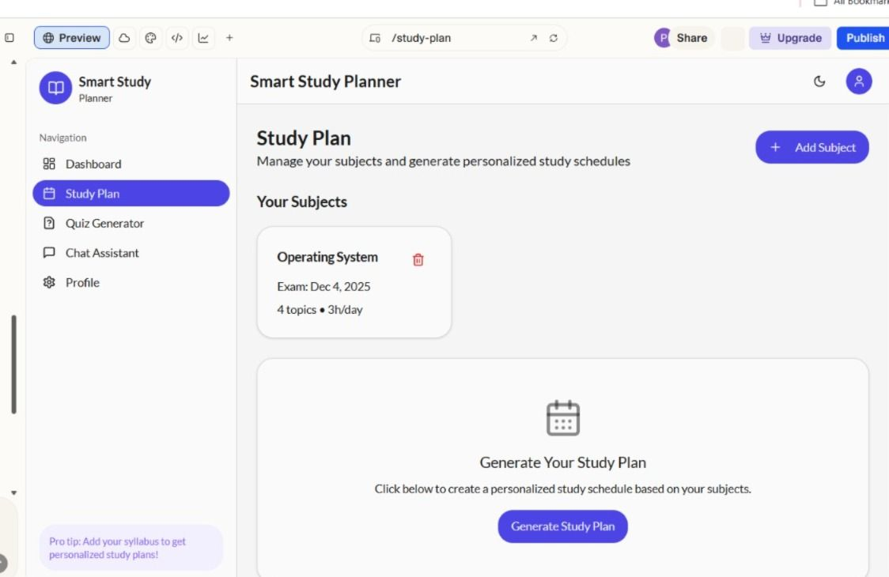
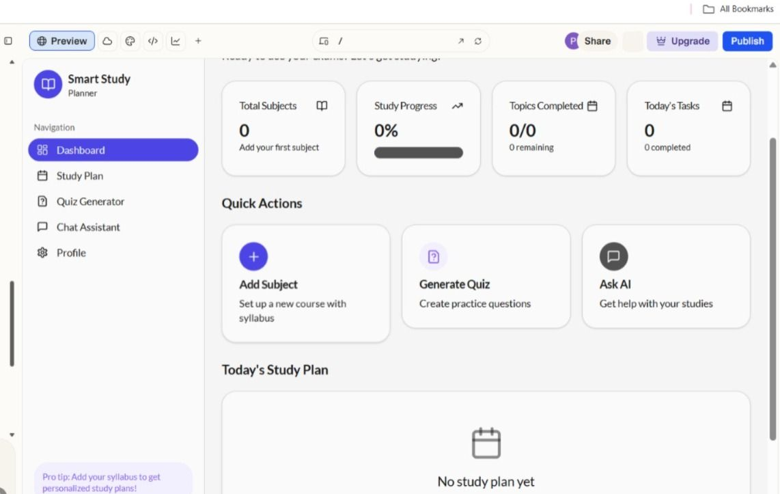

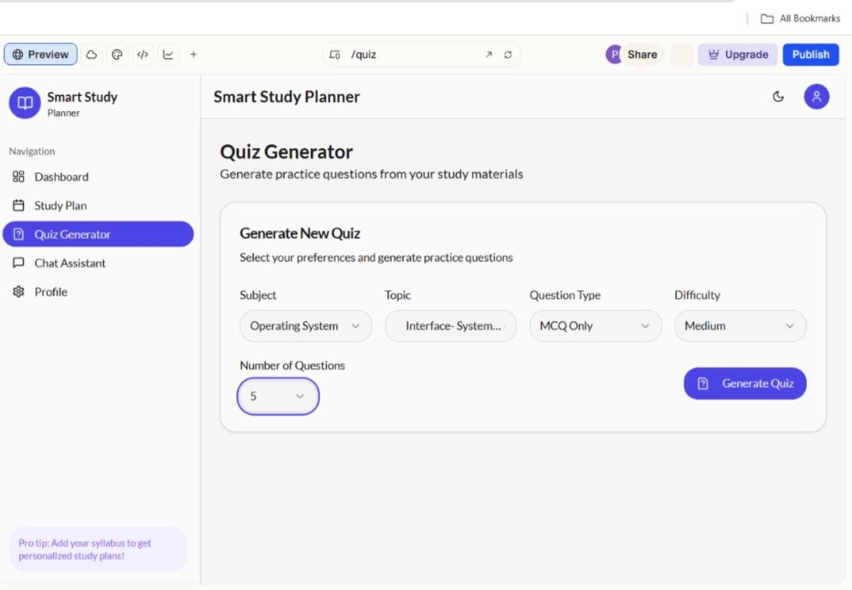
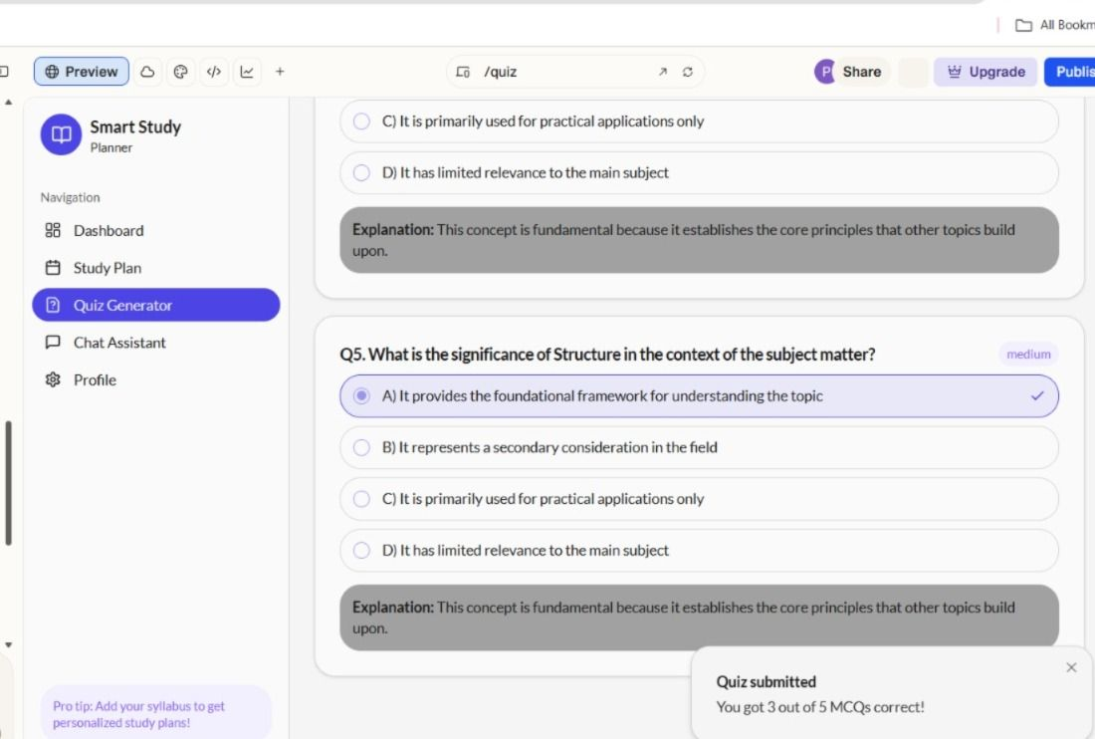
GITHUB: https://github.com/Praveena060805/AI-Powered-Study-Planner-Quiz-Generator.git
PROJECT: https://syllabus-craft-pro.lovable.app

AI Tools you can use for Step 8:
Canva AI: You can use this to design your pitch document. Download your pitch document as a PDF file and upload on GitHub

